
How to Measure Radiator Padding
Guidance for Measurement – All Measurements Must Be in Millimetres (MM)
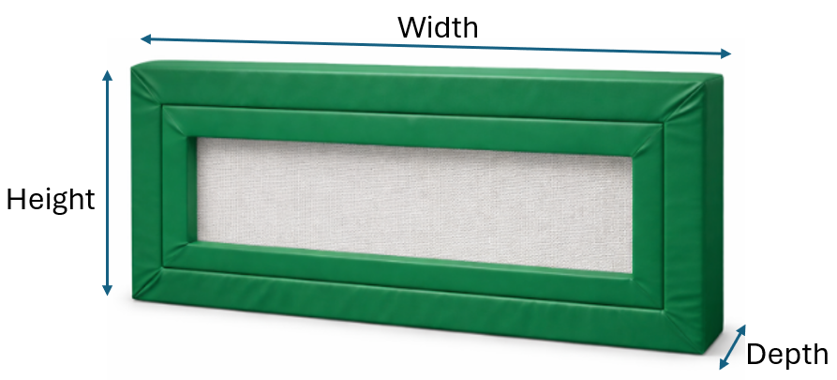
Height
Measure to the top of the radiator from floor level. Let us know if there are any obstructions above the radiator. For example, above a window
Width
Measure the overall radiator from the left to right. Be sure to include the water pipe and valve that supply the radiator in this measurement, as these components will be enclosed within the padded radiator frame.
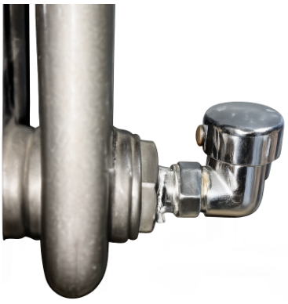

Depth
Measure how far the radiator comes out from the wall. Let us know if there are any obstructions on the wall or the flooring that may impact the depth of the radiator.
Skirting
Measure the height from the floor and depth of the skirting from the wall. Then at the bottom of the radiator, we can create a cut out so the radiator can go flush to the wall.

Sloping Top Radiator
If you require a sloping top, we will require 150mm minimum from the top of the radiator and this must be free from obstructions. If the distance between the radiator's top and the window seal is just 100mm, it's not possible to install a sloping top without affecting the integrity of the radiator.
Please note that all Radiator padding is not for electrical element heaters. Our Radiator padding is only for hot water-based systems only.

Measurements
From the Guidance, please complete all boxes in the below table. These will be the internal size.
Detail | Measurements Millimetres Only (MM) | Any Obstructions  (Yes/No) | If yes to obstructions, please provide details
Height
Width
Depth
Skirting

Detail | Is A Sloping Top Required  (Yes/No) | Any Obstructions from the Top of the Radiator  (Yes/No) | If yes, to obstructions, please provide details
Sloping Top

Please attach photo(s) separately for review.

If you have any questions, please feel free to contact Sense Sensory on 01702 810016 or email is at info@sensesensory.co.uk.
Company Number: 10233330 | VAT number: 269495837

